THE GROWTH MODEL FOR TISSUE CULTURE PLANTLETS OF ONCIDIUM

Chiachung Chen¹*
¹Chiachung Chen, Professor, Department of Bio-industrial Mechatronics Engineering, National ChungHsing University, 250 Kuokuang Road, Taichung, Taiwan
*Corresponding author: Chiachung Chen, Department of Bio-industrial Mechatronics Engineering, National ChungHsing University, 250 Kuokuang Road, Taichung, 40227 Taiwan phone: 886-4-22857562;
fax:886-4-22857135
e-mail:ccchen@dragon.nchu.edu.tw

Abstract
The effect of temperature and light intensity on in vitro growth of Oncidium plantlets was studied to develop a growth model for tissue culture of plantlets. The dry weight of plantlets served as the growth index to validate the model, and Oncidium ‘Gower Ramsey’ was used to test the model. Experimental design included the light intensity and temperature. The growth models were developed and validated by nonlinear regression analysis, and then growth parameters of models were further studied. The experimental result validated the growth model. High temperature and high light intensity treatment gave the highest dry weights for four treatments during the same culture days. The results provide useful information for the propagating of Oncidium plantlets. With the validity of the growth models, the fixed mechanism of carbon source for plantlets could be explained.

Key words: in vitro culture, logistic equation, carbon source

INTRODUCTION
In 2012, 30 million units of Oncidium orchids were produced in Taiwan. All orchids were produced from plantlets by micropropagation. The quantity and quality are considered very important for Oncidium industry.
Plantlets in vitro are cultured in a small and aseptic closed system of tissue culture vessels, which are placed on shelves in the culture room. Water and nutrition are supplied by the medium in the culture. The environment within the culture vessel consists of relative high relative humidity and low CO₂ concentrations during the light period and high CO₂ concentrations during the dark period (Fujiwara and Kozai, 1995a). Because the growth condition requires maintaining a null density of microorganisms, the gas exchange rate in the tissue culture vessel is limited (Chen and Chen, 2002). Vessels are placed on shelves in the culture room. Growth is influenced by the internal microclimate of vessels, such as light quality and quantity, air temperature and relative humidity. The optimal way to modify the internal microclimate of the vessel is to adjust the outside environment of the culture room indirectly. The measurement and model for air temperature, relative humidity and light intensity have been developed and validated (Chen 2003, 2004, 2005).
Researchers have investigated the effects of the physical environment on plant tissue culture. Rahman and Blake (1988) developed a technique for vegetative propagation of seedling jackfruit (Artocarpus heterophyllus Lam.) in vitro; shoot proliferation was optimal at 30°C and difficult to propagate at 35℃ with a 12 h photoperiod. Horn et al.(1988) studied the effect of temperature on rate of shoot multiplication of Rosa hybrids under four conditions (12, 15, 18, 24℃), and the best overall results were found at 18℃. Yamagishi (1988) studied the effect of temperature on the enlargement of in vitro bulblets of Lilium japonicum Thunb. and found that growth was better with conditions under 20℃ than 15℃ or 26℃.
Plant growth models have been adopted to describe the relationship between the plant growth index and growth time. Karadavut et al. (2010) evaluated the fitting of several nonlinear models to describe the leaf growth of five maize cultivars. de Visser and van den Berg (1998) found that only the two-parameter logistic model adequately expressed the relationship between onion bulb weight and culture days. Willcutts et al. (1998) used a logistic equation to estimate the fertilizer N requirements of lettuce. Barker et al. (2010) measured the accumulation rate patterns of herbage mass and found that the Gompertz equation could best describe the growth pattern.
A growth model for plantlets is useful for expressing the relationship between the microclimate and growth conditions during culture. This growth model can be used to evaluate the affecting factors and to optimize the production plan. Many mathematical models describe growth characteristics for agronomy and horticultural crops (Thornley and Johson, 1990). However, only a few studies have investigated plantlets cultured in vitro. The validity of the model could be used to express the carbon fixation mechanism for plantlets. Schripsema et al. (1990) assumed that the lost weight in the medium was transformed to increase in dry weight of plant cells in suspension culture in a culture flask. The estimated CO₂ concentrations in the culture flask were highly correlated with the assimilation of plant cells. Fujiwara and Kozai (1995b) applied the mathematical simulation technique to evaluate the effects of air exchange rate of culture vessels and lighting cycle on plantlet production. Fujiwara et al. (1995) developed a net photosynthesis model to estimate the effects of saccharine absorption rate and CO₂ concentration levels on the increase in dry weight of potato plantlets. Niu et al. (1996) developed an hourly net photosynthetic rate model for Cymbidium plantlets in responses to CO₂ concentration and light compensation points. Finally, Niu and Kozai (1997) proposed a growth model for potato plantlets cultured in vitro photoautotrophically in which the absorption of sugar did not need to be considered because of the use of sugar free medium. In this study, the experimental design included three levels of vessel ventilation rate and two levels of light intensity. The dry weight of plantlets measured at days 7 and 14 was used to validate the fitting-agreement of model. The correspondence of measurement data and predictive curves were observed visually
In the studies described above, the researchers have claimed the validity of these models. However, no actual data were collected to validate the models. The function of sugar absorption was not considered.
In the present study, the growth constant of growth model was assumed as the net gains of carbon source. The Oncidium plantlets were selected because of their rapid growth rate. Three growth models for plantlets were developed from a differential equation. The experimental design included two levels of temperature and irradiance. The models were evaluated with data for dry weights by culture days by use of nonlinear regression analysis. The parameters of the best fit growth model were further evaluated.

MATERIALS AND METHODS
Model development
The gain of carbon source for plantlets in vitro is assumed as follows:
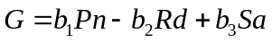 (1)
where G is the gain of carbon per plantlet of unit weight; Pn is the photosynthesis rate during the light period; Rd is the respiration rate during the dark period; Sa is the absorption rate of sugar from the medium; and b_{1,} b₂ and b₃ are conversion factors.
Pn can be calculated as follows (Fujiwara et al. 1995):
(2)
where N is the air exchange rate of the culture vessel; V is the volume of the flask; Co(t) is the outside CO₂ concentration at time t; Ci(t) is the internal CO₂ concentration at time t; CO₂₋₁ is the CO₂ concentration at the end of the light period; CO₂₋₂ is the CO₂ concentration at the start of the light period; and K₁ is the conversion factors.
Rd can be calculated as follows (Fujiwara et al. 1995) :
（3）
where C₂₋₃ is the CO₂ concentration at the end of the dark period.
The N value is limited (Chen and Chen, 2002), so the first term of equations (2) and (3) could be omitted. The values of CO₂₋₁, CO₂₋₂, and CO₂₋₃ in the fixed environment are constant (Chen, 2007). The Pn and Rd could be assumed as constants. The adsorption rate of sugar from medium Sa depends on the unit weight of plantlets (W), so equation (1) could be modified as follows:
G = b₁V[CO₂₋₁ – CO ₂₋₂] – b₂{CO₂₋₂ – CO₂₋₃] + c₃W
= D₁+D₂W (4)
where D₁ and D₂ are constants.
The growth of plantlets is assumed as a first-order chemical reaction. The quantity of growth is work at a rate proportional to the substrate level. The growth model can be proposed as follows:
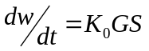 (5)
where K₀ is a constant and S is the substrate level.
For the whole system, no gain or loss for the dry materials,
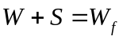 (6)
where W_{f} is the final value of W as time approaches to infinitely.
Combining equations (5) and (6),
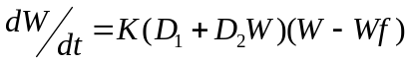 (7)
If D₁ is larger than D₂W, and D₂W could be omitted, equation (7) could be modified as follows:
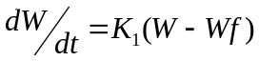 (8)
After integrating equation (8), we get:
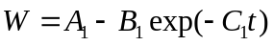 (9)
where A₁, B₁ and C₁ are constants.
Equation (9) is called the monomolecular equation (Thorhley and Joshson, 1990).
If D₂W value is larger than D₁, and D₁ could be omitted, equation (7) could be modified as follows:
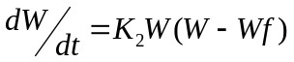 (10)
The new equation is obtained by integrating equation (10):
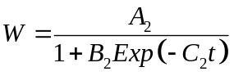 (11)
where A₂, B₂ and C₂ are constants.
Equation (11) is the three-parameter logistic equation.
At the propagation stage, young plantlets are transplanted into medium in flask. Considering the initial weights of young plantlets, equation (11) was modified as follows:
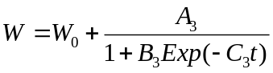 (12)
where W₀ is the initial weights of young plantlets.
This equation is the four-parameter logistic equation.
Plantlet material
The shoots of Oncidium ‘Gower Ramsey’ were transplanted to the same rooting medium for 10 days. There were 25 plantlets in a conical flask (F-1, I-Shin Co., Taiwan). The diameter of glass flasks was 100 mm and the volume 550 ml with 105 ml medium in vessels. Vessels were sealed with a black rubber stopper. A hole cover with permeable film was done in the center of rubber stopper to enhance ventilation.
The nutrient medium was composed of half strength MS nutrients, supplemented with 50 g l⁻¹ potato liquid, 6.5 g l⁻¹ agar, 20 g l⁻¹ sucrose and 1.0 mg l⁻¹ α-naphthaleneacetiv acid (NAA).

Experimental design
The culture was kept under photoperiod of 12 h light and 12 h dark. Forty culture vessels were placed on shelves in a growth chambers for each of the following four experimental designs.
1. High temperature and high light intensity (HTHL): day temperature 28℃, night temperature 23℃, light intensity 60 μmolm⁻²s⁻¹
2. High temperature and low light intensity (HTLL): day temperature 28℃, night temperature 23℃, light intensity 30 μmolm⁻²s⁻¹
3. Low temperature and high light intensity (LTHL): day temperature 23℃, night temperature 18℃, light intensity 60μmolm⁻²s⁻¹
4. Low temperature and low light intensity (LTLL): day temperature 23℃, night temperature 18℃, light intensity 30μmolm⁻²s⁻¹
Measurement of growth conditions
The growth conditions were recorded first 10 days after transplantation. Culture vessels were taken out to measure the growth of plantlets at days 10, 24, 35, 44, 51, 59, 66 and 73. Dry weights of cultured plantlets were measured by use of an electric balance (Mettler PM 400, HP, Palo Alto, CA, USA) after drying the plantlets with hot air at 80℃ for 24 hours.
Statistical analysis
The relationship between dry weight and culture days was established by use of nonlinear regression analysis. Data were analyzed by using Sigma plot v10.0 (SPSS Inc., Chicago, IL.) to evaluate the fitting agreement of the nonlinear model. Two quantitative standards, coefficient of determination R², and standard error of the estimated value s, were used to compare the fitting ability of the growth models. The adequancy of a model was evaluated by residual plots. The residual was defined as difference between the measured value and the predicted value calculated by the model. The distribution of data points in the residual plots should be a horizontal band around zero. Data points of residual plots that showed a funnel shape indicated that variance was not kept constant, and the data need to be modified for further analysis (Raymond, 2000).
In the present study, the following three growth models were adopted: monomolecular model, three-parameter logistic model and four-parameter logistic model.
RESULTS AND DISCUSSION
Data distribution of dry weights
The data distributions of the relationship between dry weights and cultured days for the four experimental designs are presented in Figs.1-4.
The wide distribution of data for each treatment showed the variation in biological characteristics. For HTHL treatment, the dry weight of cultured plantlets increased with the days in culture. The growth mechanism of plantlets was begun since the initial state in this experiment. For HTLL treatment, plantlets began to grow after 40 days in culture. The growth seemed to be stagnant during the initial period because the lower irradiance did not provide enough light intensity for growth of plantlets.
For LTHL and LTLL treatments, day/night temperature was set at 23/18℃. Plantlets began to develop after 35 days in culture. However, treatment with low irradiance seemed to produce higher dry weights during the same number of culture days.

The best fit model for Oncidium plantlets
The estimated values for parameters and comparative criteria for the three growth models with different experimental designs are listed in Table 1 and then discussed as follows.
For the monomolecular model, only data for the HTHL treatment had uniform distribution of residual plots. Other three treatments showed a clean pattern of residual distribution. The estimation errors were underestimation then became over estimation.
The monomolecular model with HTHL treatment is as follows:
(13)
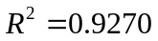, s = 0.0210
For the three-parameter model, datasets for HTHL and LTLL treatment showed uniform distribution of residual plots. The growth models for two treatments are as follows:
1. HTHL treatment:
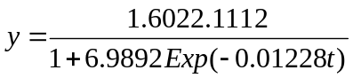 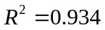, s = 0.0119 (14)
2. LTLL treatment:
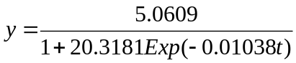 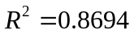, s = 0.0278 (15)
The typical residual plots of LTHL treatment for three models (Fig. 5.) indicate that the clean patterns of residual plots could be found for the monomolecular and three-parameter logistic models. The uniform distributions of residual plots were expressed by the four-parameter logistic model.
For the four-parameter model, datasets had uniform distribution of residual plots. Therefore, the four-parameter model could be an adequate model for Oncidium plantlets with the four treatments. The growth models for two typical treatments are as follows:
1. HTHL treatment:
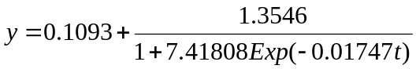 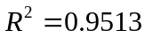, s = 0.0221 (16)
2. LTLL treatment:
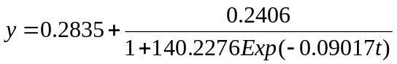 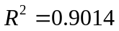, s = 0.0245 (17)
In comparing R² and s values, the four-parameter logistical model was the best fit. The predictive curves for this model were used for further analysis.
Effect of temperature and irradiance on plantlet growth
The predictive curves for the four-parameter growth model with the four treatments (fig. 6) showed that dry weights of plantlets with HTHL treatment were the highest during the same culture days. The plantlet growth was better with LTLL treatment than HTLL and LTHT treatments.
Because of the wide diversity of datasets, the effect of culture environment on these growth characteristics of plantlets is difficult to evaluate directly by visual method. The predictive curves obtained from the growth model could provide a clear pattern to indicate the effect of factors on growth.
Variables of the growth model could provide some biological meaning for the specific growth rate. C₃ values for HTHL, HTLL, LTHL and LTLL treatments were 0.01747, 0.06634, 0.01101 and 0.09017, respectively. The C₃ value indicates the growth rate. Because of the negative value of C₃ in the model, the lower the C₃ value, the higher the growth rate of the plantlets. The C₃ values for four treatments showed that HTHL treatment had the highest growth rate.
Effects of physical environment on the plantlet growth have been reviewed in detail (George and Davies, 2008). Most of research works have focused on photoenvironment. Studies of the temperature effect are limited (Rahman and Blake, 1988; Horn et al. 1988). In the present study, temperature had a significant effect on the growth rate and maximum dry weight of Oncidium ‘Gower Ramsey’ plantlets. This information is important for plantlet propagation and serves as a set value for the culture environment.
The growth rate was better with LTLL than HTLL and LTHL treatments. Effect of the interaction of temperature and light intensity on growth of Oncidium plantlets needs further studies. The technique developed in this study could be used to study factors affecting the propagation of other plantlets.
Validity of carbon fixation mechanism of Onicidium plantlets
The monomolecular equation assumes that carbon source of plantlets is obtained from the photosynthesis function. The result of the present study showed that this equation was validated only with HTHL treatment. The assumption of four-parameter logistic equation considered that carbon source of plantlets was provided by the adsorption of sugar from the medium and the effect of initial mass of young plantlets transplanted into medium. This equation could be used to express growth conditions of different temperatures and light intensities.
The adequate environment for Oncidium orchids was higher temperature (25-30℃) and light intensity (600-700 μmol m⁻²s⁻¹) (Hew and Yong, 1994). The monomolecular equation was validated only in HTHL treatment. The result indicates that the carbon fixation of plantlets by photosynthesis is significant only in HTHL treatment. If the environment was inadequate, the main source of the carbon fixed for plantlets was the adsorption of sugar from the medium.
The results of this study led to the following conclusions:
- High temperature and high light intensity treatment gave the highest dry weights in four treatments during the same culture days.
- The four-logistic growth equation was the adequate equation for all treatments.
3. The monomolecular equation was validated only in high temperature and high light intensity (HTHL) treatment. The result indicates that carbon fixation of plantlets by photosynthesis is significant only in HTHL treatment.
4. Main source of the carbon fixed by plantlets was the adsorption of sugar from the medium under the inadequate environment.
5. The technique developed in this study could be used to study factors affecting the propagation of plantlets in other species.

ACKNOWLEDGEMENTS
The authors would like to thank the National Science Council of the Republic of China for financially supporting this research under Contract No NSC-95-2313-B-005-019.

REFERENCES
Barker D., Ferraro F., Nave R., Sulc R., Lopes F., Albrecht K. (2010). Analysis of herbage mass and herbage accumulation rate using Gompertz equations. Agronomy Journal, 102: 849-857.
Chen C. (2003). Development of a heat transfer model for plant tissue culture vessels. Biosystems Engineering, 85: 67-77.
Chen C. (2004). Humidity in plant tissue culture vessels. Biosystems Engineering, 88: 231-241.
Chen C. (2005). Lighting distribution models of fluorescent for plant micropropagation. Biosystems Engineering, 90: 295-306.
Chen C., Chen J. (2002). Measurement of gas exchange rates for plant tissue culture vessels. Plant Cell, Tissue and Organ Culture, 71: 103-109.
Chen C. (2007). In situ measurement of microclimate for the plantlets cultured in vitro. Biosystem Engineering, 95:413-423.
de Visser C., van den Berg W. (1998). A method to calculate the size distribution of onions and its use in an onion growth model. Scientia Horticulturae, 71:129-143.
Fujiwara K., Kozai T. (1995a). Physical microenvironment and its effects. In: Aitken-Chistie, J., Kozai, T., Smith M.A.L. (Eds.), Automation and Environment Control in Plant Tissue Culture. Kluwer Acadmic Publisers: 319-369.
Fujiwara K., Kozai T. (1995b.) Control of environment factors for plantlets productions-with some mathematical simulation. In: Proceeding Ecophysiology and Photosynthetic in virto cultures, Kluwer Academic Publishers, Dordrecht, The Netherlands:109-120.
Fujiwara K., Kira S., Kozai T. (1995). Contribution of photosynthesis to dry weight increase of in vitro potato cultures under different CO₂ concentrations. Acta Horiculturae, 393: 654-661.
George E.F., Davies W. (2008). Effects of the physical environment. In: George E.F., Hall M.A., de Klerk G.. –J. (eds.) Plant Propagation by Tissue Culture, vol. 1, Springer Verlag: 423-464.
Hew C.S., Yong J.W.H. (1994). Growth and photosynthesis of Oncidium ‘Goldiana’. Journal of Horticultural Science and Biotechnology, 69:809-820.
Horn W., Schlegel G., John K. (1988). Micropropagation of roses (Rosa hybr.). Acta Horiculturae, 226:623-630.
Karadavut U., Palta C., Kokten K., Bakoglu A. (2010). Comparative study on some non-linear growth models for describing leaf growth of maize. International Journal of Agriculture and Biology, 12: 227-230.
Niu G.., Kozai T., Kitaya Y. (1996). Simulation of the time course of CO₂ concentration in the culture vessel and net photosynthetic rates of Cymbidium plantlets. Transactions of the American Society of Agricultural Engineering, 39:1567-1573.
Niu G., Kozai T. (1997). Simulation of the growth of potato plantlets cultured photoautotrophically in virto. Transactions of the American Society of Agricultural Engineering, 40:253-260.
Rahamn M.A., Blake J. (1988). Factors affecting in vitro proliferation and rooting of shoots of jackfruit (Artocarpus heterophyllus Lam.). Plant Cell, Tissue and Organ Culture, 13:179-187.
Raymond, M. (2000). Classical and Modern Regression with Applications. 2nd ed., Duxbury, Pacific Grove CA: 209-248.
Schripsema J., Mije A. H., van Iren F., ten Hoopen H.J.G.., Verpoorte, R. (1990). Dissimilation curves as a simple method for the characterization of growth of plant cell suspension cultures. Plant Cell, Tissue and Organ Culture, 22:55-64.
Thornley J.H.M., Joshson I. R. (1990). Plant and Crop Modelling: A mathematical approach to plant and crop physiology. Clarendon Press. Oxford, Great Britain :74-89.
Willcutts J., Overman A., Hochmuth G.., Cantiffe D., Soundy P. (1998). A comparison of three mathematical models of response to applied nitrogen: A case study using lettuce. HortScience 33: 833-836.
Yamagishi M. (1988). Effects of culture temperature on the enlargement, sugar uptake, starch accumulation, and respiration of in virto bulblets of Lilium japonicum Thunb. Scientia Horticulturae, 73:239-247.
Table 1. - Estimated values and comparative criteria of parameters for three growth models and four experimental designs in Onicidium plantlets.
Growth model | Parameters  & criteria | HTHL | HTLL | LTHL | LTLL
Monomolecular model | A₁  B₁  C₁  R²  s  Residual plots | 4.996  4.7492  8.5190×10⁻⁴  0.9270  0.0220  UD | 4.1980  3.9513  5.4908×10⁻⁴  0.650  0.0326  CP | 5.7374  5.5207  5.3216×10⁻⁴  0.7472  0.0352  CP | 4.2940  4.0722  8.1896×10⁻⁴  0.8357  0.0312  CP
Three-parameter logistic model | A₂  B₂  C₂  R²  s  Residual plots | 2.1112  6.9892  0.01228  0.9345  0.0199  UD | 3.2101  11.7914  0.007496  0.687  0.0308  CP | 7.1847  30.9464  0.009644  0.7988  0.0314  CP | 5.0609  20.3181  0.01038  0.869  0.0278  UD
Four-parameter logistic model | W₀  A₃  B₃  C₃  R²  s  Residual Plots | 0.1093  1.3546  7.41808  0.01747  0.9513  0.0195  UD | 0.2926  0.6971  472.6685  0.06634  0.816  0.0239  UD | 0.2873  0.2570  1245.736  0.11007  0.9019  0.0223  UD | 0.2835  0.2406  140.2276  0.09017  0.9014  0.0245  UD
UD, Uniform distribution; CP, Clear pattern; HTHL; day temperature 28℃, night
temperature 23℃, light intensity 60 μmolm⁻²s⁻¹; HTLL, day temperature 28℃,
night temperature 23℃, light intensity 30 μmolm⁻²s⁻¹; LTHL, day temperature
23℃, night temperature 18℃, light intensity 60μmolm⁻²s⁻¹; LTLL, day
temperature 23℃, night temperature 18℃, light intensity 30μmolm⁻²s⁻¹.
Legend:
Fig. 1. The data distribution of dry weights and culture days for the HTHL treatment, day temperature 28℃, night temperature 23℃, light intensity 60μmolm⁻²s⁻¹.
Fig. 2. The data distribution of dry weights and culture days for the HTLL
treatment, day temperature 28℃, night temperature 23℃, light intensity
30μmolm⁻²s⁻¹.
Fig. 3. The data distribution of dry weights and culture days for the LTHL
treatment, day temperature 23℃, night temperature 18℃, light
intensity 60μmolm⁻²s⁻¹.
Fig. 4. The data distribution of dry weights and culture days for the LTLL
Treatment, day temperature 23℃, night temperature 18℃, light intensity
30μmolm⁻²s⁻¹.
Fig. 5. The residual plots of LTHL treatment (day temperature 23℃, night
temperature 18℃, light intensity 60μmolm⁻²s⁻¹) using three growth models.
Fig. 6. The predictive curves of four-parameter growth model for four treatments.

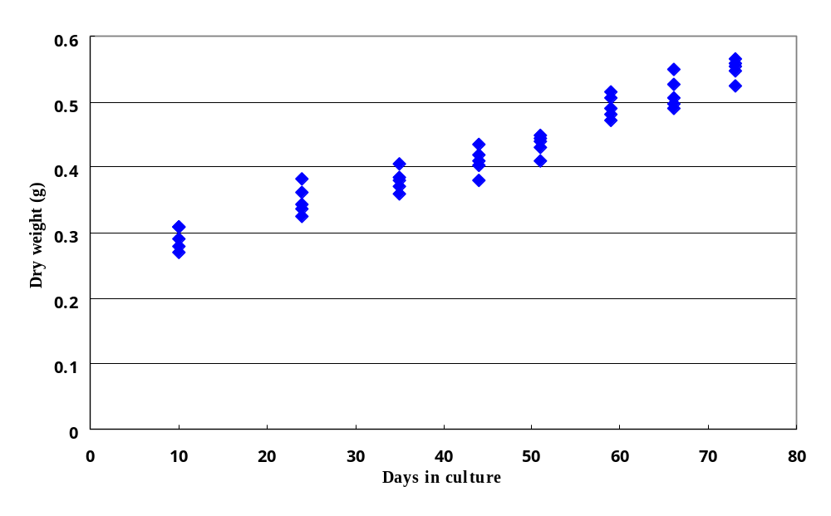
Fig. 1. The data distribution of dry weights and culture days for the HTHL treatment, day temperature 28℃, night temperature 23℃, light intensity 60μmolm⁻²s⁻¹.

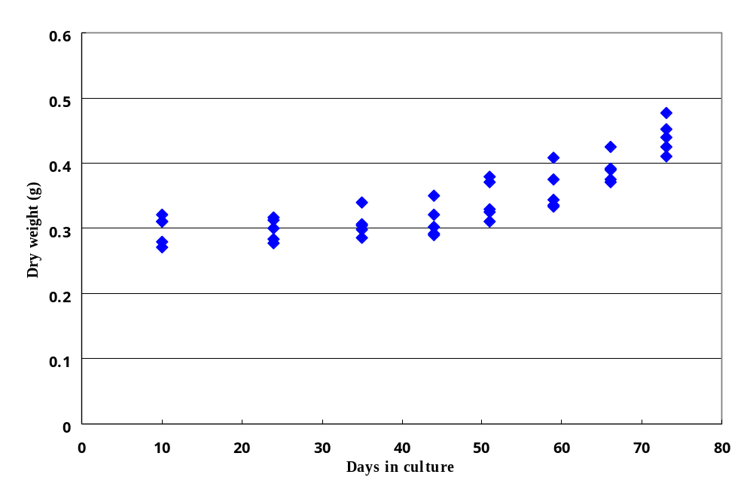Fig. 2. The data distribution of dry weights and culture days for the HTLL
treatment, day temperature 28℃, night temperature 23℃, light
irradiance 30μmolm⁻²s⁻¹.

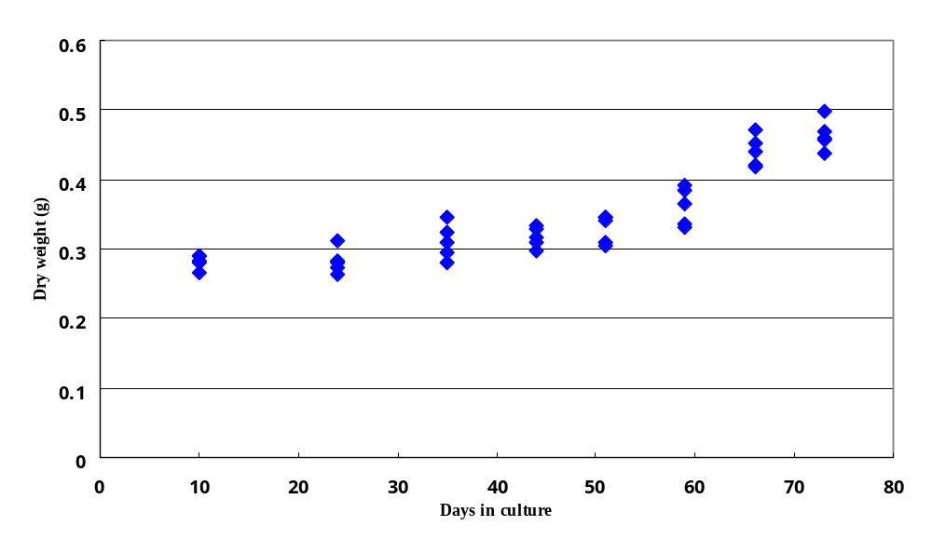
Fig. 3. The data distribution of dry weights and culture days for the LTHL
treatment, day temperature 23℃, night temperature 18℃, light
irradiance 60μmolm⁻²s⁻¹.

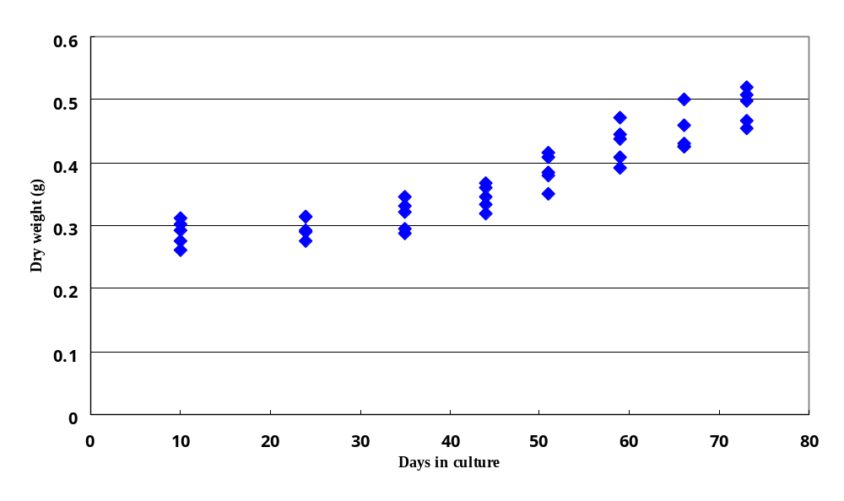
Fig. 4. The data distribution of dry weights and culture days for the LTLL
Treatment, day temperature 23℃, night temperature 18℃, light
irradiance 30μmolm⁻²s⁻¹.

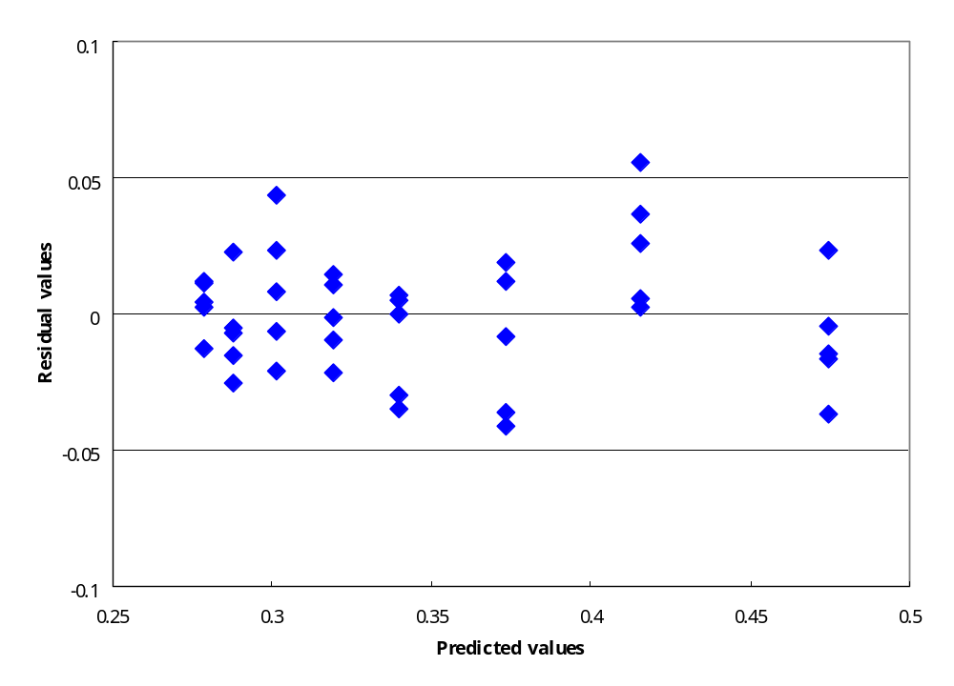
a. the Monomolecular model
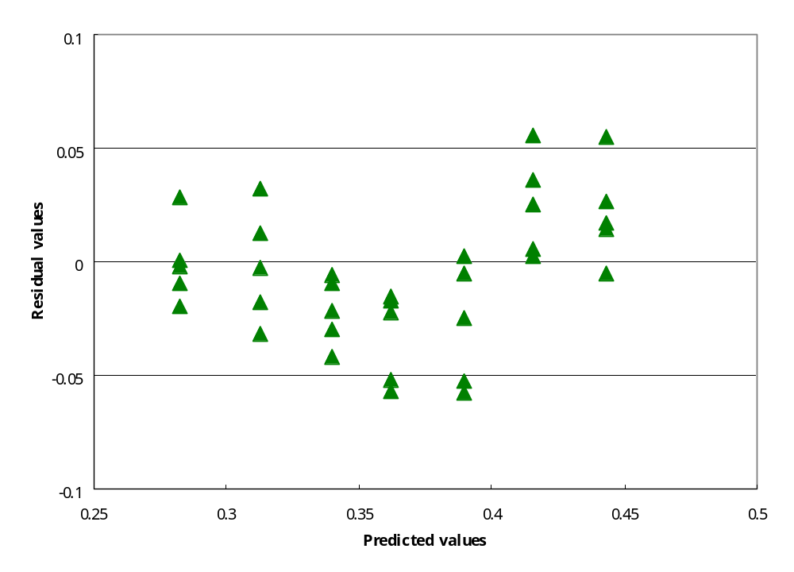
b. The three-parameter logistical model

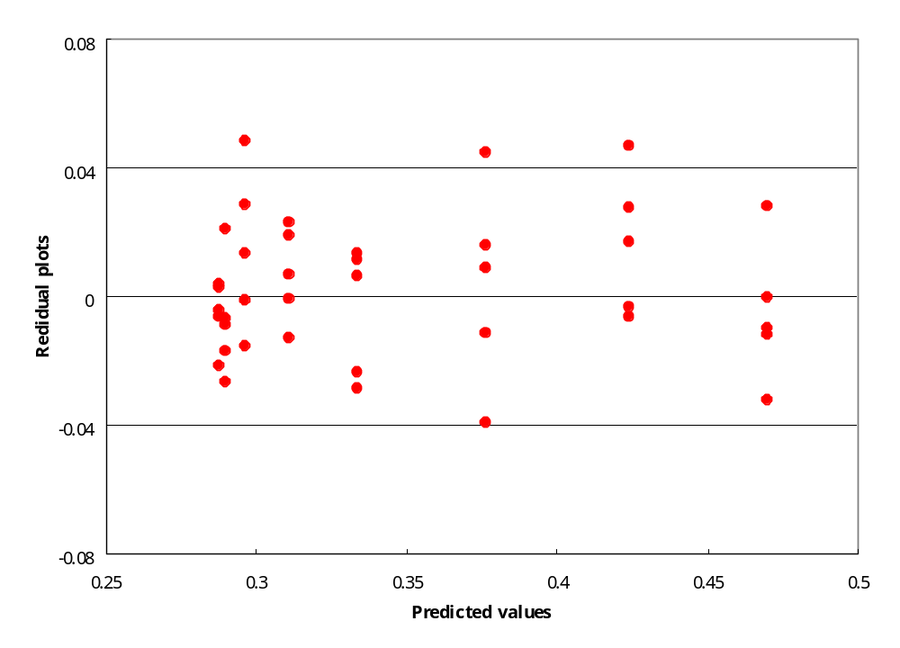

c. The four-parameter logistical model

Fig. 5. The residual plots of LTHL treatment (day temperature 23℃, night temperature 18℃, light intensity 60μmolm⁻²s⁻¹) using three growth models.

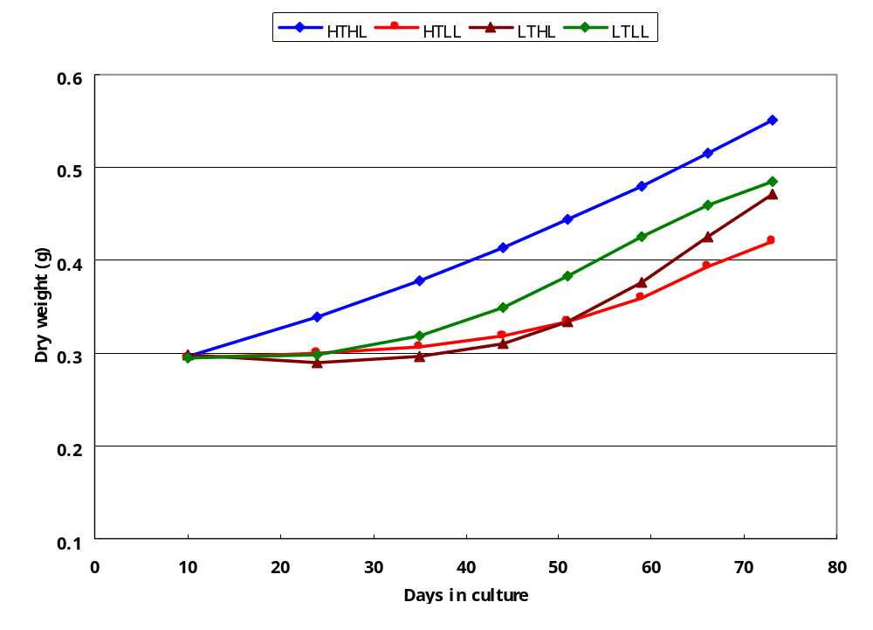

Fig. 6. The predictive curves of four-parameter growth model for four treatments.

